PÇ-Link User Manual
For SE and CMPE Departments
Any found bug or suspicious behaviour should be reported on http://toliga.com:8081 as a new issue. This process is necessary to debug and keep the software healthy, available, and working throughout the entire alpha-beta period.
PÇ-Link application is a web application for easy calculation and management of students’ program outcome resuls and averages. The current hosting server is placed in the Frankfurt/Germany, and the VPS service is provided by DigitalOcean. The source code is located in a private repository on Atlassian BitBucket.
This manual defines the basic interactions with the PÇ-Link application.
- When a user enters the http://toliga.com/se/ or http://toliga.com/cmpe/, the page shown in Figure 1 is presented. This page is the main page of the application.
In the main page, several options/functions are served depending on what the user want to do.
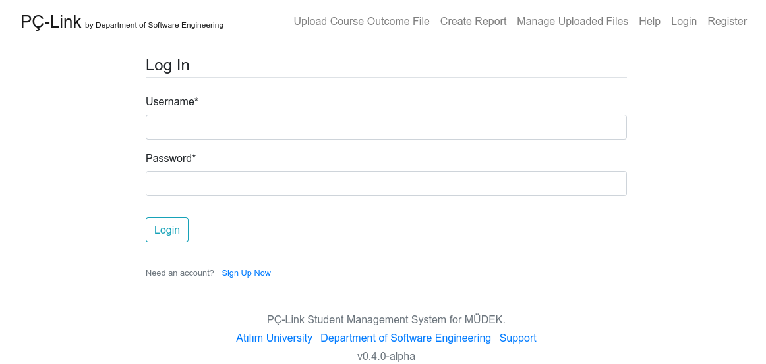Figure 1: Main page of PÇ-Link application.
- Upload Course Outcome File: Login required. This option redirects you to the CSV upload page.
- Create Report: Login required. This option redirects you to the report creationg page. Also you can download a CSV file containing all students with their respected course outcome averages.
- Manage Uploaded Files: Login required. This option redirects you to a page which you can mange the previously uploaded files. You can delete or edit the existing uploads.
- Help: Not implemented.
- Login: Login page.
- Register: Registration page.
- Users must be logged in to the system to make uploads or reporting or any change. The registration process is started by clicking to the Register button from top navigation bar. This button redirects to a registration page shown in Figure 2.
All fields are required. Note that, this page will be disabled when all previously defined users are registered.
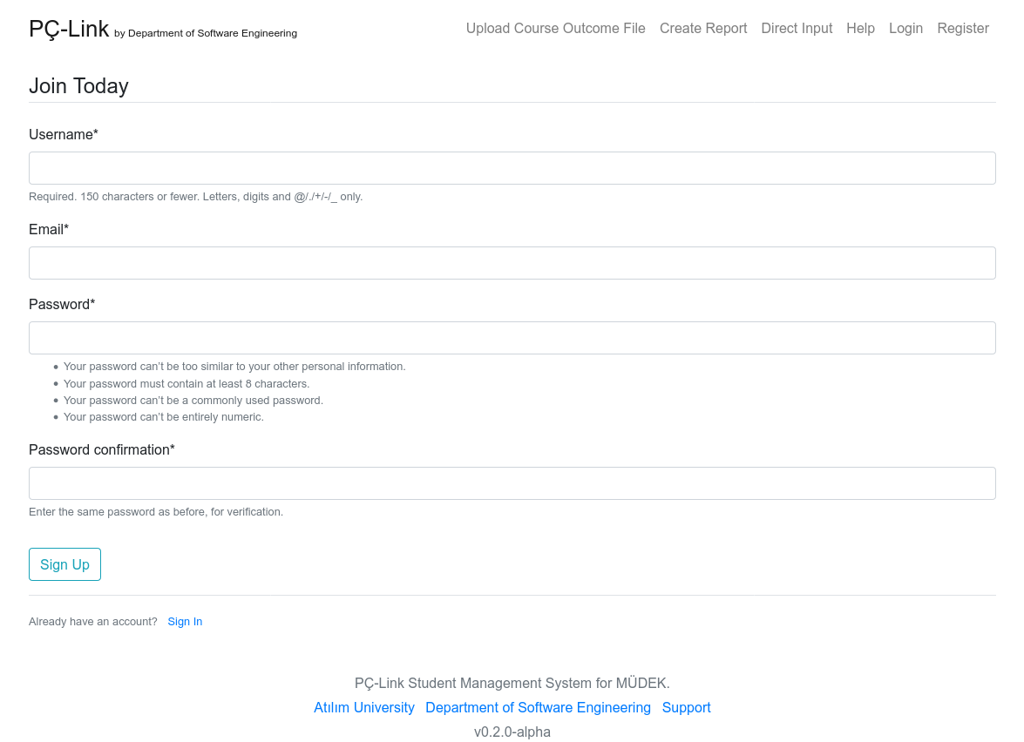Figure 2: Registration page of PÇ-Link application.
- After the registration process, users will be redirected to a page shown in Figure 3.
Login page is straightforward. When users log into the system, they can interact all of the defined functionality.
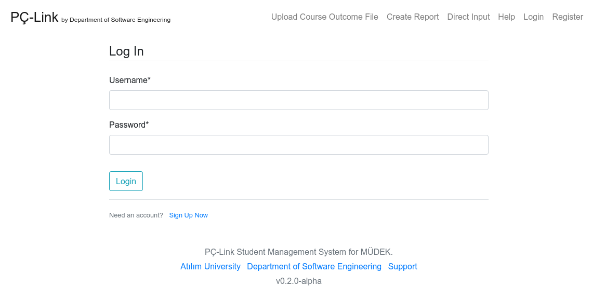Figure 3: Login page of PÇ-Link application.
There is no SSL/TLS encrpytion in the site traffic. Users be careful about their choice of password since the hash of the password can be stolen with the man-in-the-middle attacks.
- A logged in user is automatically redirected to course outcome upload page as shown in Figure 4.
In this page, all form elements are required. User must choose the related course with the CSV file from Select a course* combo box, the related semester from Select a semester:* combo box and upload the CSV file from the Upload the PÇ File:* file upload field.
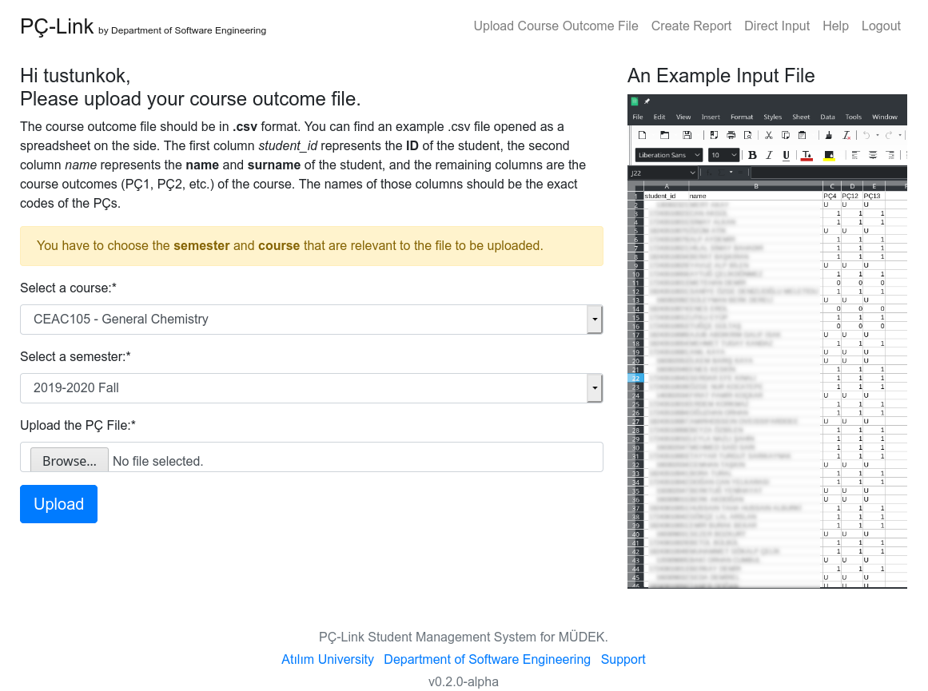Figure 4: Course outcome upload page of PÇ-Link application.
The CSV file has to be in a certain and consistent format. The format structure is explained in the page itself and is quoted below.
The course outcome file should be in .csv format. You can find an example .csv file opened as a spreadsheet on the side. The first column student_id represents the ID of the student, the second column name represents the name and surname of the student, and the remaining columns are the course outcomes (PÇ1, PÇ2, etc.) of the course. The names of course outcome columns should be the exact codes (case-sensitive) of the PÇs (e.g. PÇ1, PÇ7a, PÇ7b, etc.).
When the user presses the upload button, CSV file is sent to the server. There is no need to seperate the students of different departments. PÇ-Link can differentiate the students from CMPE and SE depending on the uploaded site. This process is automatically handled.
- A user can create filtered reports and export unfiltered reports by clicking the Create Report button from the top naviagtion bar.
In this page, a user can create and display reports filtered by the filtering options shown in right side of Figure 5. Notice that, these filters are not going to be applied when exporting a CSV or XLSX.
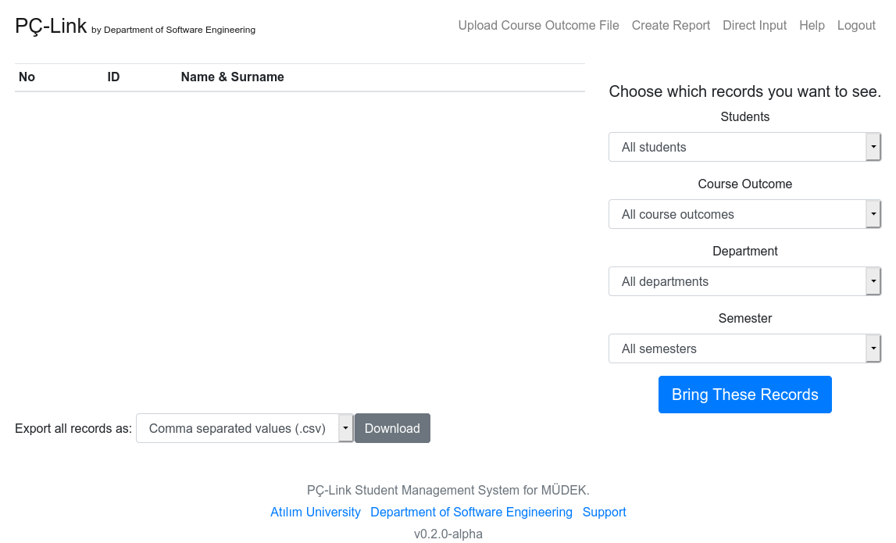Figure 5: Create report page of PÇ-Link application.
Users can choose the details of the record they want to create and give a overall course outcome value. If the record already exists, then the existing record is updated, otherwise a new record is created.
- Bug reports and other issues can be created in the following link by self-registered reporters.
http://toliga.com:8081
For all other problems with the system, send an email to tolga.ustunkok@atilim.edu.tr.

Users can only see the currently active semester in the combo box. An administrator can change the current active semester from the main admin page.

